Unveiling Market Insights : Analysing Spending Behaviour And Identifying Opportunities For Growth.

Project Report

1. **Introduction**
   1. **Overview**

Marketing is an organizational function and a set of processes for creating communicating , and delivering value to customers and for managing customer relationships in ways that beneﬁt tha

organization and it's stakeholders.

* 1. **Purpose**
     1. **Needed as part of tha yearly planning process with in tha marketing functional areas.**
     2. **Explain tha present and future situations of organization .**
     3. **Set goal & make projections .**
     4. **Permits the monitoring of each action and it's result so that control maybe implemented.**

1. **Problem Deﬁnition & Design Thinking**
   1. **Empathy Map**

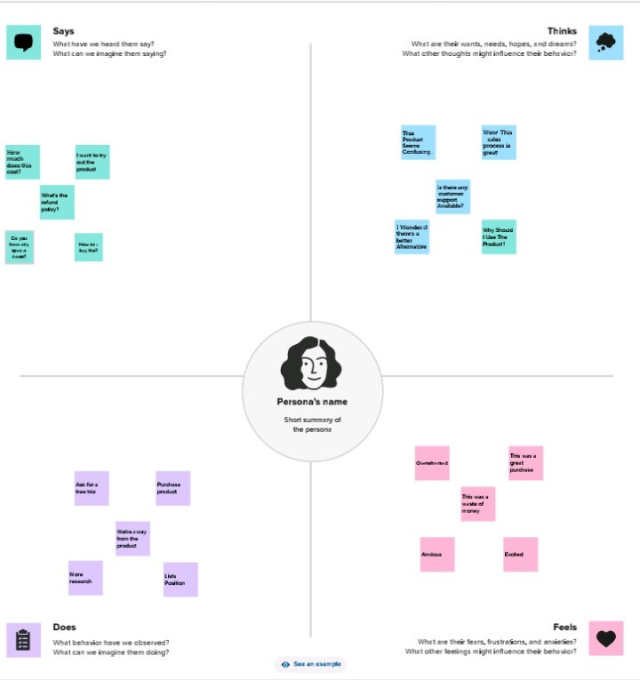

* 1. 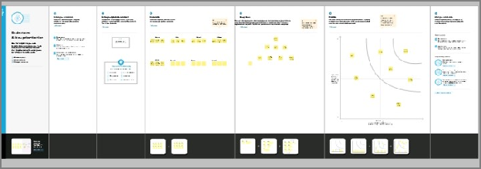**Brainstorming Map**

1. **Result**

Result, making also known as objective marketing or performance marketing , is a type of

advertising in which you pay only based on the actual performance of tha ads published. Cookies or

universal and conversion pixels are sum of tha tools used by marketing experts to monitor user actions.

1. **Advantages & Disadvantages Advantages:**
2. **It eliminates middlemen.**
3. **It lower marketing budget.**
4. **High chance of success because of direct contact with targeted audience.**
5. **More proﬁt because of less cost and elimination of middlemen.**
6. **Suitable for small business ﬁrms. Disadvantages:**
7. **Not suitable for well-established companies.**
8. **Customers may feel irritating and annoying.**
9. **It has low response rate.**
10. **High initial costs.**
11. **Less conversion rate.**
12. **Application**

The company plans to expend upon Flow works'proven marketing strategy to attract new customers by implementing innovative marketing automation technologies, which included the use of

the company 's extend -to-social referal marketing application.

1. **Conclusion**
2. **In conclusion, marketing is not simply about advertising and selling. Marketing is about identifying a need and fulﬁlling that need.**
3. **Marketing research is crucial for ensuring that a company can understand the mindset of its customers.**
4. **A business organization's marketing objective should be consistent and specify the primary concern of the organization.**
5. **Future Scope**
6. **The digital marketing industry is worth**

$68 billion and it is growing at a 40% growth rate.

1. **For job seekers it is best opportunities to enter in digital marketing ﬁeld because the future is very bright.**
2. **40% of contemporary business these days are dependent solely on digital marketing & it is estimated that around 90% of business will go digital in recent times.**